CS 6327 Video Analytics

yxs173130

Assignment1

For this assignment, I use Python to achieve the objecting tracking task. For the convenience of this assignment, I make the menu bar as the main menu. Here are the all functions and process which provided.

1. Under “Video” option, we can create the video and save the video in the file. Moreover, we still can perform on live capture tracking for the object.
2. After capturing the video(otherwise we can use the video provided in the file called orangle.mp4), we can go “Frames” option to “Select the Frames”, we can press ‘s’ on the keyboard to select the moment to save. After selecting frames, we can see these pictures by clicking “Show the Frames”.

Note: We must select frames first, otherwise we can not do the process of converting to HSV, detecting the object, adding noise and removing noise.

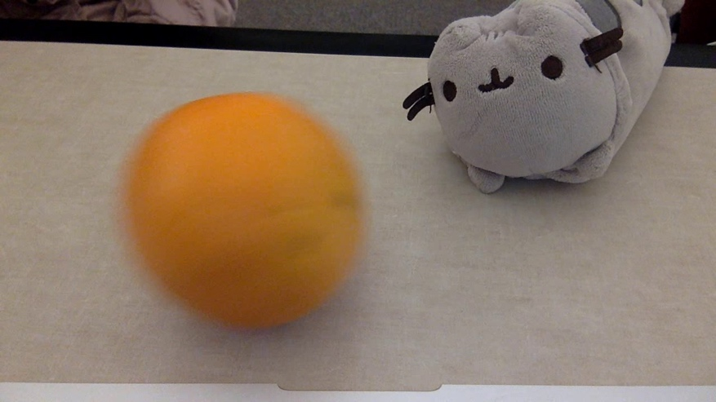

Original Frame

1. Under “HSV” option, there are ways to convert BGR to HSV. The first way is use built-in function cvtColor() to achieve that, another way is writing my own code to achieve that.



HSV Frame

1. Then we can detect the object by the color detection. In this assignment, the color what I detect is orange.



white object in dark background

1. Make noises. We always select the first frame which I save to add the noises. We still are able to remove noise by median filter.

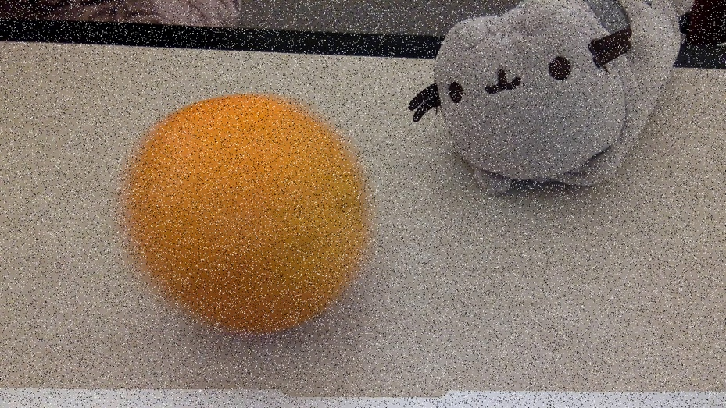

salt and pepper noises

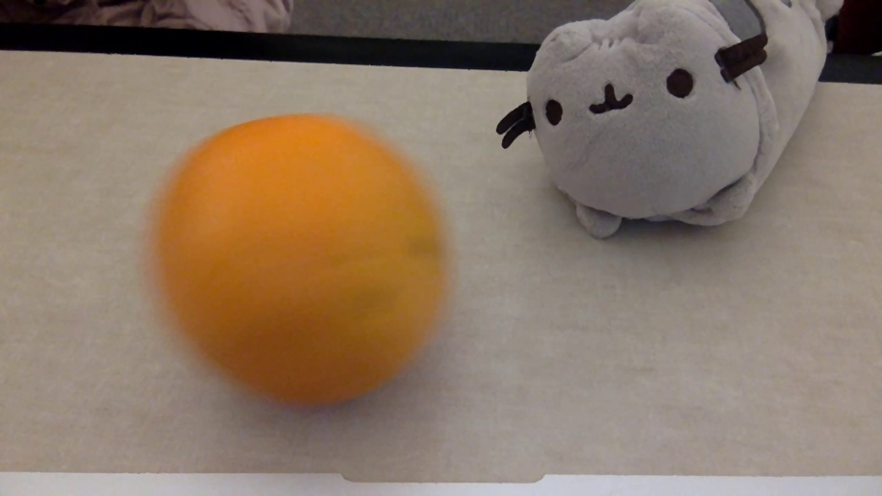

smoothing